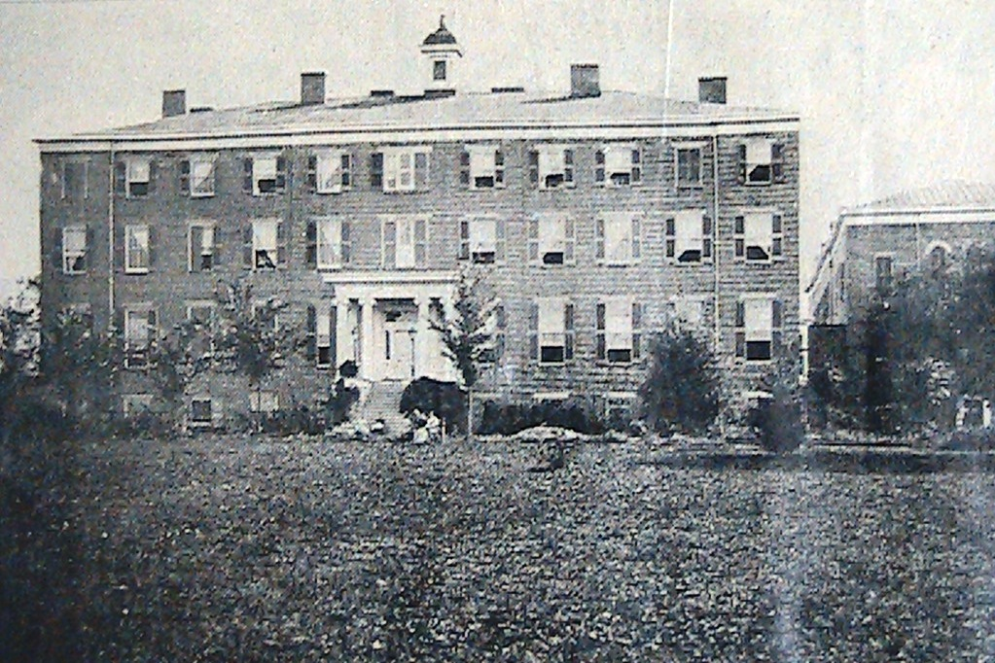
The Ursuline Convent in 1866 at St. Martins. Illustration 93

“The Ursulines during the Civil War”

The St. Ursuline Convent in St. Martins was founded in 1845 by a group of French Nuns under the leadership of Mother Superior Julia Chatfield. It was then and is now, as Chatfield College, a place for peace and education but during the Civil War even the Ursuline was involved.
Hidden in the woods along a tree lined lane on the far side of Solomon’s Run the St. Ursuline Convent was not easy to find but that didn’t keep parents searching for the best education for their young daughters from locating it. The first class began with thirteen students but very quickly the fame of the school grew and so did the size of the classes. By the 1860’s the campus had grown to three buildings and over 130 students, 100 boarders and 30 local students.
The curriculum offered a complete French and English education, including training in music, fine arts, and modern languages. The Nuns also conducted a Junior College that trained older students in the profession of teaching. The students were from five years old to young adults. Young ladies of all religious denominations were admitted and at any time up to thirty percent of the girls were Protestants.
Students were from all walks of life and from most areas of the United States. Young ladies from Ohio were the largest group at St. Ursuline but girls from Maine to Minnesota could be found on the roster. Southern girls also found their way to St. Martins. The soft southern tones of Kentucky, Louisiana, Georgia, and other
southern states could be heard in every classroom.
As the war drew closer and the turmoil and uncertainty grew more and more southern girls were sent to the relative safety of northern Brown County. Then when the war broke out the young ladies from the Deep South found it impossible to go home through the battle lines so may stayed on in St. Martins and swelled the number of boarders to overflowing until the war us over.
It had rained all day, as twilight rolled in. Mist lay on the ground. Heavy fog was in the hollows. Night came; wet, windy, and very dark. The man on horseback was a Confederate spy. His name was Tom Hines and he was on an important mission in Brown County. It was not a mission for the Confederacy but for himself. His mission was to kidnap a young woman from the Ursuline Academy at St. Martins. Nancy Sproule, his fiancé, was packed and ready to go with Tom when he presented the forged letter from Nancy’s father to the Mother Superior. The letter explained that Nanty’s father was very sick and Nancy was to return to her home in the South with Mr. Hines. Believing the letter to be true the Mother Superior gave the young couple her blessing and wished them, “God’s speed”. Within minutes the two were on the way south but not towards an ailing parent. By midnight the couple was in northern Kentucky and was married in the parlor of a justice of the peace.

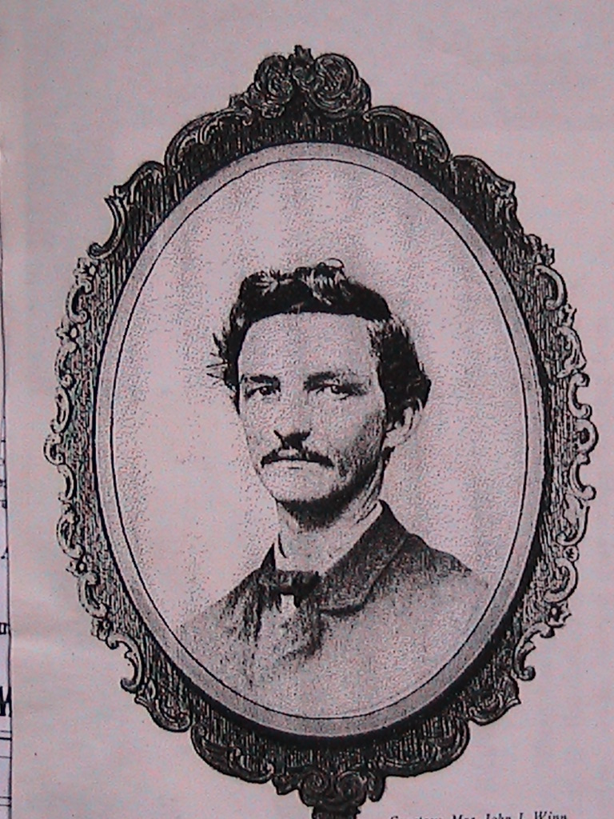
Capt. Thomas Hines, CSA

Word reached the Ursulines on July 15th, 1863, that Morgan’s Raiders were on the way and to take precautions. Everyone was told to all stay inside behind looked doors and shutters. Hoof beats were heard but the long wooded lane hid the Covent from the raiders view and no one rode onto the campus. Only Father Cheymol’s horse and buggy that had been hidden deeper in the woods were found and taken.
During the winter of 1864 General William Tecumseh Sherman lead his army of 60,000 Union soldiers through Georgia and left a sixty mile wide by three hundred mile long swath of destruction behind them. Now they had turned north and as they entered South Carolina, the state that started the war, Gen. Sherman told his troops to take off their gloves in South Carolina and don’t be as kindly as they had been in Georgia. Sherman’s soldiers entered the state capital, Columbia, in early January, 1865.
Even today no one knows who started the fires. The cotton bales that the Confederate defenders had lined many of the streets with and the wooden buildings were ablaze. Strong winds spread the fires quickly. The Confederates had retreated from the city and the Union forces made no attempt to control the destruction. In the midst of the terror a Nun entered Gen. Sherman’s headquarters and asked for protection for her convent. Sherman asked her why he should do that and she replied that as a young Nun she had had his daughter as one of her students at the St. Ursuline Convent at St Martins. The General asked her name and recognized it when she told him. His daughter had written him several times about her favorite teacher. That Nun was now Mother Superior in Columbia. General Sherman said he didn’t think he could save the building but he sent a detail to protect the young students and Nuns as they walked through the burning city to safety at a convent in the country.
Union Generals Ewing, Scammon, and Rosecrans also had daughters that attended the little school down the lane and over the stone bridge that crossed Solomon’s Run. A peaceful place then and a peaceful place now but even such a place could not escape the Civil War.

Confederate Captain Thomas Hines. Illustration 94

